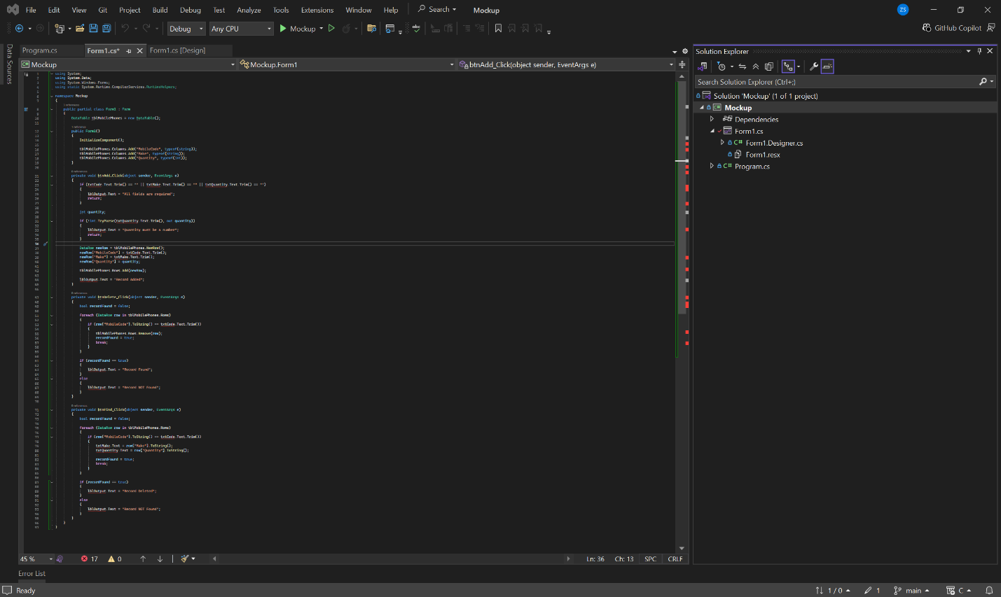

SECTION C.3 — Software Testing Report
1.3.1 Application Description

The Mobile Stock Capture Application is a Windows Forms application created for a retail inventory environment. The main purpose of the application is to allow staff members to capture and manage mobile phone stock records in a simple way.

The application allows the user to add a new mobile phone record, search for an existing record, and delete a record by using the MobileCode. Each action gives feedback to the user through the lblOutput label, which helps the user understand whether the action was successful or not.

The main inputs captured by the system are the MobileCode, Make, and Quantity. These fields are used to identify the phone, describe the brand or make of the phone, and record how many units are available in stock. 1.3.2 Test Cases Table

| Test Case | Input | Expected Result | Actual Result | Status |
|---|---|---|---|---|
| TC001 - Add valid record | MobileCode: M001, Make: Samsung, Quantity: 10 | The record must be added to tblMobilePhones and lblOutput must display “Record Added”. | The record was added and “Record Added” was displayed. | Pass |
| TC002 - Add record with empty fields | MobileCode: blank, Make: Apple, Quantity: 5 | The system should not add the record and should display a validation message. | The system displayed “All fields are required”. | Pass |
| TC003 - Add record with invalid quantity | MobileCode: M002, Make: Nokia, Quantity: abc | The system should reject the input because Quantity must be numeric. | The system displayed “Quantity must be a number”. | Pass |
| TC004 - Delete existing record | MobileCode: M001 | The system should delete the matching record and lblOutput should display “Record Found”. | The record was removed and “Record Found” was displayed. | Pass |
| TC005 - Delete non-existing record | MobileCode: M999 | The system should not delete anything and lblOutput should display “Record NOT Found”. | The system displayed “Record NOT Found”. | Pass |
| TC006 - Find existing record | MobileCode: M001 | The system should find the record and display the related Make and Quantity values. | The record details were displayed and lblOutput showed “Record Deleted”. | Pass |
1.3.3 Identified Defects

During testing, a few issues were identified in the application.

The first issue is that the Delete button displays “Record Found” after deleting a record. Although this matches the instruction in the question, it can confuse the user because the action performed is a delete action, not only a search action.

The second issue is that the Find button displays “Record Deleted” when a record is found. This is also confusing because the button is only supposed to search for a record, not delete it.

Another issue is that the application needs validation to prevent blank values from being saved. Without validation, incomplete stock records could be added, which would reduce the accuracy of the inventory data.

The Quantity field also needs numeric validation because stock quantity should only contain numbers. Text values or symbols should not be accepted in this field.

The final issue is that the records are stored in a DataTable during runtime only. This means the data will be lost when the application is closed.

1.3.4 Recommendations for Improvement

The application should include clear validation for all required fields before allowing the user to add a record.

The Quantity field should only accept numeric values so that incorrect stock data is not saved.

The message displayed by the Delete button should be changed from “Record Found” to “Record Deleted” to make the system feedback clearer.

The message displayed by the Find button should be changed from “Record Deleted” to “Record Found” because the button is used to search for records.

The application should be connected to a proper database so that records are saved permanently and can still be accessed after the program is closed.

A DataGridView can also be added to show all captured mobile phone records in a clear table format.

